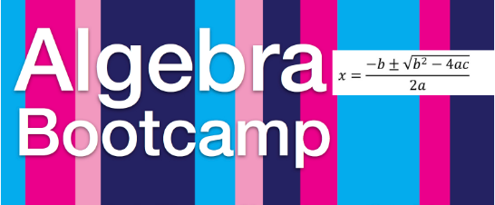

Come join your classmates and teachers for an Algebra boot camp **Saturday April 22nd and Saturday April 29th from 9-12** at Clearwater high school in the media center.

Algebra boot camp will be focused on review for the upcoming End of Course exam; Hosted by Mr. Maley, Ms. Salamin and Mr. Espinoza.

Dress code not in effect during boot camp, snacks will be provided, prizes will be awarded for students.

Students who come to both days of the boot camp will be entered into a drawing for a $25 gift certificate to Abe’s Place.

Any question can be sent to :

[salamini@pcsb.org](mailto:salamini@pcsb.org)

[maleyt@pcsb.org](mailto:maleyt@pcsb.org)

[espinozaf@pcsb.org](mailto:espinozaf@pcsb.org)